Nextion Multiple Stepper Control Screen Descriptions

V: 11

Splash Screen

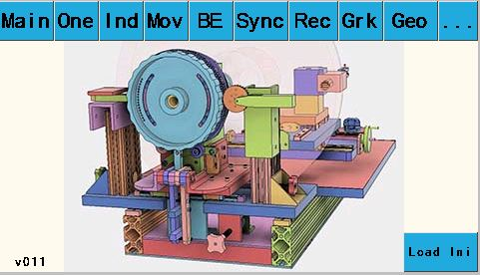

Purpose: Initialize program

Buttons explanation: Touching one of the top row buttons will take you to that screen. The ‘Load Ini’ button in the lower right corner will load motor settings from an ini file.

2-Axes Driver Board 4-Axes Driver Board

# Main Screen

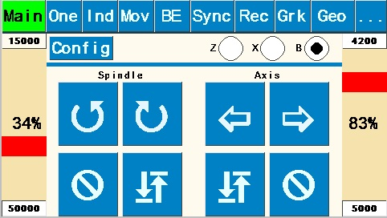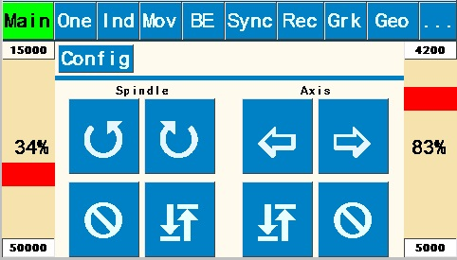

Purpose: Allows direct control of spindle speed and direction and auxiliary axis speed and direction independent of one another. Typically used for continuous spindle and/or continuous Axis motion (turning or facing cuts, continuous rose engine patterns on cylindrical or face surfaces., etc.).

Buttons explanation:

* “” (Counterclockwise) and “” (Clockwise) rotational arrows indicate direction of the Spindle and Axis. Rotation continues until “” (Stop) is pushed.
* Right and left speed bars (for Spindle and Axis, respectively, are shown as a percentage of maximum speeds set on the Configuration Screen for “Main” and “Z Axis”, respectively. Max speed and acceleration entry fields are shown at the top and bottom of each speed bar. These fields may also be set using the Configuration screen.
* “ “(Return): Returns the spindle or the selected axis to the start point of the previous operation.

# Number Pad Screen

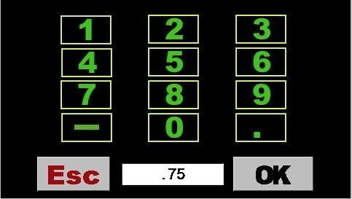

Purpose: This screen appears whenever any numerical value on any screen is tapped. Revise the number in the box by tapping the box multiple times to “backspace” over each digit or decimal point, and then re-enter the new value using the number pad buttons. Pressing “OK” saves the number back to the value box on the previous screen and returns user to that screen.

# Synchronization Screen

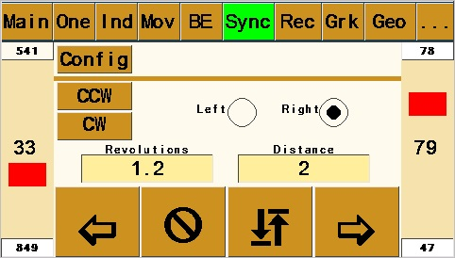 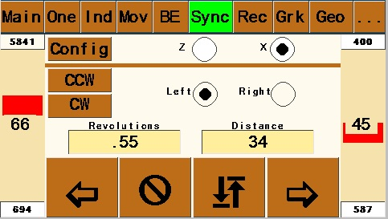

Purpose: Synchronizes the Spindle and Auxiliary Axis to produce helical patterns or threads on cylindrical surface of workpiece or to produce spirals on a face surface.

Buttons explanation:

* “Left” and “Right” determine whether helix runs clockwise or counterclockwise on the piece.
* “” (Clockwise) and “” (Counterclockwise) index the spindle for the next cut path – either clockwise or counterclockwise per user design. Amount the spindle will index uses the value in “Size” set in the box on the Index #1 Screen (this value could be either in divisions of a circle or degrees depending upon which option is toggled on Index #1 Screen).
* “Revolutions” variable value determines how far around the piece the helix will travel based on the spindle rotating. The value of .5 illustrated will rotate spindle 360x.5=180 degrees.
* “Distance” variable value determines the cut length (amount of Z axis movement) and is dependent upon value entered in Setup Screen for “Distance/360”.
* Right and left speed bars (for Spindle and Axis, respectively, are shown as a percentage of maximum speeds set on the Configuration Screen for “Sync” and “Z Axis”, respectively. Note that slowest value on speed bars will “control” the other value.
* “”(In) and “”(Out) determine whether cut is made toward or away from headstock. Pattern will run the pre-determined “Distance” and then stop and wait for return direction instruction. User chooses whether to cut in both directions or retract cutter and return to start without cutting.
* “ “(Return): Returns both the spindle and the axis to the start point of the previous operation.
* See below for procedure for using the Synchronization Screen for thread cutting.

# Reciprocation – Axis Screen

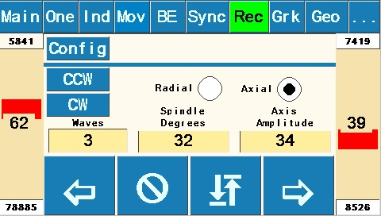 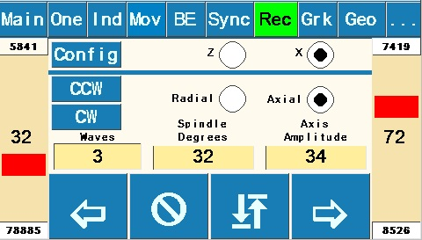

Purpose: Synchronizes Spindle and Auxiliary Axis to produce a sharp-pointed reciprocating pattern along the longitudinal cylindrical surface of workpiece: /\/\/\/\/\/\. Works by reversing spindle direction alternately while Z axis continues in the same direction.

Buttons explanation

* “CW” (Clockwise) and “CCW” (Counterclockwise) index the spindle for the next reciprocating cut path – either clockwise or counterclockwise per user design or desire. Amount the spindle will index uses the value set in the “Size” box on the Index #1 Screen (this value could be either in divisions of a circle or degrees depending upon which option is toggled on Index #1 Screen).
* “Wave Count” variable sets number of individual waves /\ to be cut along the cylinder.
* “Amplitude” variable sets “height” of each wave in degrees of rotation.
* “Distance” variable determines the cut length for entire pattern (amount of Z axis movement) and is dependent upon value entered in Setup Screen for “Distance/360”.
* “”(In) and “”(Out) determine whether cut is made toward or away from headstock. Note that “”(In) starts with a downward move and “”(Out) starts with an upward move (test your individual machine and apparatus to verify – your results may vary). Pattern will run the pre-determined “Distance” and then stop and wait for return direction instruction. User chooses whether to cut in both directions or retract cutter and return to start without cutting.
* “ “(Return): Returns both the spindle and the axis to the start point of the previous operation.

# Reciprocation – Spindle Screen

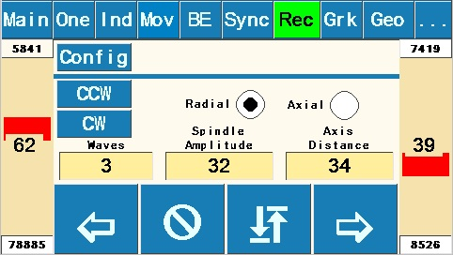 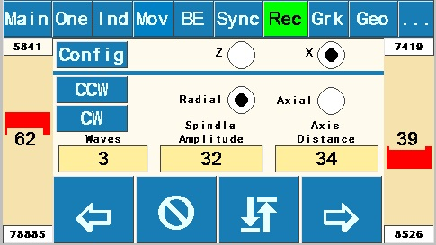

Purpose: Synchronizes Spindle and Auxiliary Axis to produce a sharp-pointed reciprocating pattern along the circumferential surface of a cylindrical workpiece: It works by alternately reversing Z axis direction while spindle continues rotating in the same direction.

Buttons explanation

* To navigate to this screen, start with “Rec1” and toggle from (default) “Z Axis” to “Spindle”.
* “In” and “Out” move the Z Axis to the next pattern starting position. Z Axis movement will be the value of “Distance” set on the Move Screen.
* “Return” button rotates the spindle to the pattern start point.
* “Acceleration” and “Speed” values for this screen are set here for both Spindle and Z Axis. See notes on value limitations under Configuration Screen explanation. Because of synchronization of the spindle and Z Axis speeds, one of the maximum speeds will control the other.
* “Wave Count” variable sets number of individual waves ( > ) to be cut along the cylinder.
* “Degrees” variable sets the circumferential distance around the cylinder for the total pattern. Entering 360 would wrap the pattern all the way around the cylinder; entering 90 would condense the whole pattern around just 90 degrees of the cylinder.
* “Amplitude” variable sets “height” (distance along Z Axis) of each wave and is dependent upon value entered in Setup Screen for “Distance/360”.
* “” (Clockwise) and “” (Counterclockwise) rotational arrows determine the direction of cut around the spindle. Pattern will run the pre-determined “Degrees” around spindle and then stop and wait for return direction instruction. User chooses whether to cut in both directions (either on the same cut path or on subsequent path) or retract cutter and return to the origin point without cutting.
* “ “(Return): Returns both the spindle and the axis to the start point of the previous operation.

# One Screen (Single Stepper Screen)

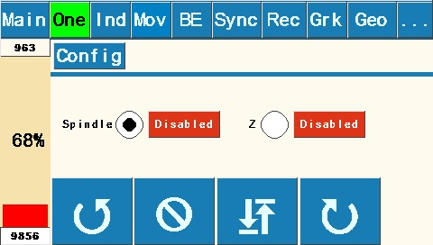 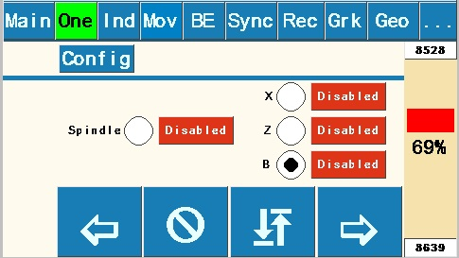

Purpose: Allows control of spindle or an axis speed and direction. Useful for allowing manual control of the Z Axis (or other movement) while spindle rotates to set speed and direction. Also useful for secondary spindle operation such as higher or lower speed functions than the Main Screen.

Buttons explanation

* “Enabled” shows status (either “Enabled” or “Disabled”) of either Spindle stepper motor or an Axis stepper motor as selected. If enabled, the motor is in locked status; if disabled, the selected motor can be repositioned. Default is “Disabled”. Primary use for these buttons is to lock the spindle or axis while performing another operation.
* “” (Clockwise) and “” (Counterclockwise) rotational arrows indicate direction of the Spindle. Rotation continues until “Stop” is pushed.
* Speed bar is shown only for the selected axis or spindle.

# Index Screen

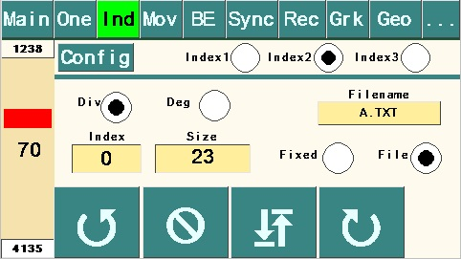

Purpose: Allows indexing spindle for use in index work or other uses.

Buttons explanation

* “Div” radio button sets the indexing to number of divisions of a full rotation, toggling to “Deg” sets the indexing to number of degrees.
* “Index” box keeps a running “count” of the number of indexing moves.
* “Size” variable is in either “Divisions” of a circle or “Degrees”, depending upon which is toggled.
* Speed bar is shown as a percentage of maximum speeds set on the Configuration Screen for “Index”.
* Note that the “Size” value on the Index #1 is used by the “CW” and “CCW” indexing movements on the Synchronization Screen and the Reciprocation – Axis Screen in either “Divisions” or “Degrees”, depending upon which is toggled.

# Index #2 Screen with microSD enabled

Purpose: Allows variable index sizes to be retrieved sequentially from a file stored on a microSD card. This feature could be used to place evenly spaced features (such as barleycorns) around the circumference of an ellipse (i.e. equal division of the ellipse), with the angular movement in degrees precalculated using a CAD program.

If “Fixed” radio button is selected, the “Size” setting is used for indexing the same as the default Index #2 Screen. Selecting the “File” radio button looks for a file on the microSD card with a file name the user enters in the “Filename” window using Keypad below.

The file format is ASCII text (numbers and decimal only) with each number on a new line, saved to the microSD card using a separate computer. Because the SD Card library only supports the 8.3 or Short File

Name convention, the file name must be a maximum 8 characters + a period + three-character extension (thus the 8.3); the name is not case sensitive. It's not necessary to have the extension, but the limit for the name is 8 characters when no extension is used. Multiple files can be loaded onto the microSD card for use on one or more work pieces as desired.

The counterclockwise and clockwise arrows determine direction of spindle movement during indexing. When using the “File” version, each successive index will read successive file numbers off the microSD card (in either “Div” or “Deg” as selected on this screen). When the end of the file is reached, “Size” will be reset to 0. The “Index” value will be increased when indexing clockwise and decreased when indexing counterclockwise. The read position of the file can also be set by editing the “Index” value.

The “Div” and “Deg” radio buttons and the “Enabled” button work the same as on the other Index screens above.

# Keypad

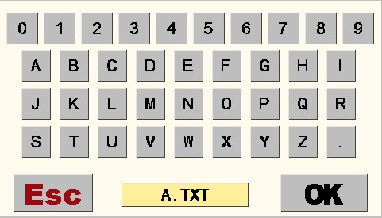

Purpose: Entering the “Filename” for Index #2 Screen with microSD enabled. See Number Pad Screen for usage. Press “OK” when finished.

# Move Screen

|  |  |  |
| --- | --- | --- |
|  |  |  |

Purpose: Moves the Z Axis a specific distance and direction. This could be used to cut a flute or other element along Z Axis of specific length, or used on the end face of a cylinder if set up to drive the X Axis, to move a specific distance to produce rose engine basket weave or other repeating design element on the cylindrical surface of the workpiece, or to plunge in and out of cylindrical surface to do index work if set up for X Axis.

Buttons explanation:

* “Distance” variable sets amount of movement along Z Axis and is controlled by Setup Screen Value “Distance/360”.
* “Count” tracks the number of moves.
* “Total” tracks total distance of movement (adding in one direction, subtracting in the other.
* “In” and “Out” indicate direction of the Axis movement. Movement will continue for “Distance” set and then stop and wait for another move instruction, either repeating move or returning to origin.
* Speed bar is shown as a percentage of maximum speed set on the Configuration Screen for “Z

Axis”.

# Geo Screen

|  |  |  |
| --- | --- | --- |
|  |  |  |

Purpose: Create Rose or single stage geometric chuck patterns, see Wikipedia [Rose (mathematics)](https://en.wikipedia.org/wiki/Rose_(mathematics)).

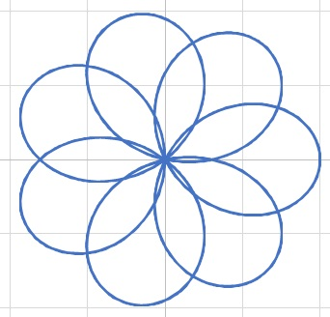

Buttons explanation:

* “n” numerator.
* “d” denominator.
* “k” ratio of n/d.
* “Amplitude” variable sets “height” (distance along Z or X Axes) of each lobe and is dependent upon value entered in Setup Screen for “Distance/360”.
* “” (Clockwise) and “” (Counterclockwise) rotational arrows indicate direction of the Spindle. Rose pattern continues until “Stop” is pushed.
* “ “(Return): Returns both the spindle and the axis to the start point of the rose pattern.

# Grk (Greek Key) Pattern Screen

|  |  |  |
| --- | --- | --- |
|  |  |  |

Purpose: Create Greek Key or Meander patterns. The Pattern page has six built-in patterns. Patterns are created by moving either the spindle or one of the axes individually.

Buttons explanation:

* Pattern: Create a Greek Key using one of the built-in patterns.
* File: Create a Greek Key by reading values from a file. See below.
* Radial or Axial: Creates a pattern radially (circumferentially) of axial.
* 4a and 4b: Create a pattern four segments wide. 4a is eight segments tall, 4b is thirteen segments tall.
* 3a and 3b: Create a pattern three segments wide. 3a is four segments tall. 3b is eight segments tall.
* 2a and 2b: Create a pattern two segments wide. 2a is three segments tall. 2b is six segments tall.
* Segment Length: Specifies the length of the shortest Z or X axis segment. Each pattern will have segments which are a multiple of the shortest segment.
* Patterns Per 360: Specifies how many individual patterns will fit in 360 degree rotation of the spindle. This controls the length of the shortest spindle segment.
* Count: Determines the actual number of patterns to create. Setting it less than the Patterns Per 360 value will leave a space in the pattern. Setting it larger will recut the same pattern. This is useful when you want to cut a pattern deeper.

# Grk (Greek Key) File Screen

|  |  |  |
| --- | --- | --- |
|  |  |  |

Purpose: Create Greek Key or Meander patterns by reading values from a file.

Buttons explanation:

* Filename must be in 8.3 format: 8 character name, a period, and a 3 character extension. It isn’t necessary to have the full 8.3 characters. Note: Apple computers may automatically add “.txt” to the name.
* Segments: Values in the file are interpreted as a multiplier of the Segment Length for the Z and X axes and as a multiplier of the calculated segment size for the spindle. If floating point numbers are found, the decimal portion is ignored.
* Actual: Values in the file are used as the length of the move. Floating point numbers are valid.

File format:

The file must be plain text (ASCII).

Each line in the file must begin with an axis identifier letter and end with the length of the move, except for the Comment and End lines.

Identifiers:

* ; Comment: Begins with a semi-colon, “;”, and may have up to 25 characters. There is no limit on the number of comment lines in a file. Each comment line must have a least one additional character.
* E End: Begins with a capital “E”. All files **must** have this as the last line in the file.
* S(Plus count of vertical segments in the pattern). Required for all radial patterns.
* A(Plus count of horizontal segments in the pattern). Required for all axial patterns.
* L(Plus multiplier or actual length) Specifies a move to the left in a pattern.
* R(Plus multiplier or actual length) Specifies a move to the right in a pattern.
* U(Plus multiplier or actual length) Specifies a move up in a pattern.
* H(Plus multiplier or actual length)V(Plus multiplier or actual length) Specifies a coordinated move with the spindle and the active axis. H is a horizontal move with the axis and V is vertical move with the spindle. Each move is a leg of a right triangle.

D(Plus multiplier or actual length) Specifies a move down in a pattern.

Four axes boards can also move the cutter into or away from the workpiece.

* O(Plus multiplier or actual length) Moves the cutter away from the workpiece.
* I(Plus multiplier or actual length) Moves the cutter into the workpiece.

Example file:

; Pattern 2a

S3

A2

R2

D2

L1

U1

L1

D2

E

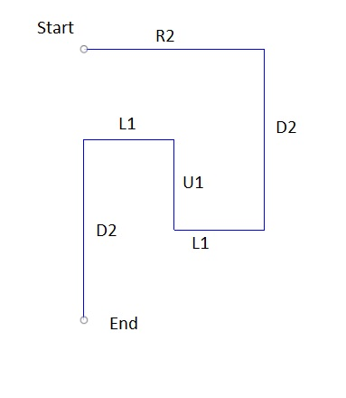

# Setup Screen

|  |  |  |
| --- | --- | --- |
|  |  |  |

Purpose: The factors on this screen control how speeds and distances are determined. The left column shows settings on the Nextion. Touching one of the text boxes allows you to edit that value. The right column shows settings stored on the Teensy. These are read only and should match the left column settings.

Buttons explanation:

* The software is currently set up for 32 Microsteps, 200 Steps/360, and 9 Gear Ratio for the spindle. This assumes a stepper motor with 200 steps per revolution and the “standard” configuration for the

MDF Rose Engine with a 12 tooth spindle motor drive pulley and 108 tooth driven pulley yielding a Gear Ratio of 9. Once set, the values for the Spindle will most likely remain the same unless changes are made to spindle drive setup.

* Likewise, the software assumes that Z axis is 32 Microsteps, and that you are using a stepper motor with 200 Steps/360. The 32 and 200 values for Axis will most likely remain the same.
* The “Distance/360” is the distance the Z axis carriage moves in one revolution of its stepper motor. It is a value arrived at empirically by measuring the movement of the Z Axis using a dial indicator or other appropriate device while the stepper motor revolves a set number of turns. This can be accomplished by entering a value in “Distance/360” such as 1, then using the Move Screen to move a “Distance” of 20 while measuring. This should turn the motor through 20 full revolutions. Divide the distance traveled by 20 and enter calculated value into “Distance/360”. If the total distance moved in 20 revolutions is insignificant, use a larger “Distance” number like 50 (or even 100). Note that best practice is to remove backlash from the Axis mechanism prior to the measurement run by moving the axis in the same direction. It may be possible to get a starting point for Distance/360 by calculation calculating the stepper pulley to driven pulley ratio, and/or the thread pitch.

Finally, it’s important to note that if you use different pieces of apparatus (such as a cross-slide, a spherical or a curvilinear apparatus) with the Z Axis, each will likely have a different value for Distance/360, so keep track of these separately for each piece of apparatus.

* The Enable “High” and “Low” radio buttons for both Spindle and Z Axis are set to “Low” by default, which is the correct setting when using the DRV8825 Stepper Drivers. The “High” setting is for use for some external stepper drivers.
* “Hand” should be set to the thread direction of the axis leadscrew. If using a Hardinge compound sliderest with a left-hand thread, for example, set “Hand” to “L”. If using an apparatus with a righthand threaded rod, for example, set “Hand” to “R”. Test to verify.
* “Back” button returns to the previous screen.
* “Limits” button activates the Limits Screen.
* “Returns” button activates the Returns Screen.
* “Refresh”: Retrieves settings stored on the Teensy. These settings should match the left columns which are stored on the Nextion.

Limits screen

|  |  |  |
| --- | --- | --- |
|  |  |  |

Purpose: Set pin numbers for limit switches.

Returns screen

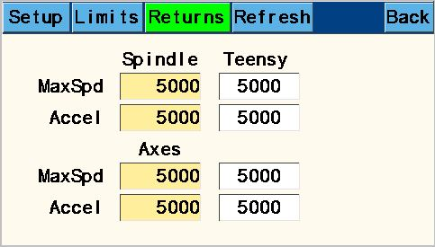

|  |  |  |
| --- | --- | --- |
|  |  |  |

Purpose: Set speed and acceleration for return actions.

# Configuration Screen

|  |  |  |
| --- | --- | --- |
|  |  |  |

Purpose: Set speeds and acceleration values for all other screens with speed bars. Values shown are for the previously active screen. Each of the functional screens have unique settings for all of the variables. The left column shows settings on the Nextion. Touching one of the text boxes allows you to edit that value. The right column shows settings stored on the Teensy. These are read only and should match the left column settings.

Buttons explanation:

* Set “MaxSpd” and “Accel” values for each of the screens listed. The upper rows control the lathe spindle in each screen, the lower rows control the Axis. Note that if you use different pieces of apparatus (such as a cross-slide, a spherical or a curvilinear apparatus, etc.) with the Z Axis settings, it will probably be desirable to reset the MaxSpd for some uses. Keep a record of different settings used for each piece of apparatus. Generally speaking, the “MaxSpd” settings can be set anywhere between 100 and 50000 with 10000 being a safe starting point. Acceleration can be set between 100 and 500000 with 1000 being a good starting point.
* “Show Config” runs a routine to return the current settings stored on the Teensy. Settings are also stored on the Nextion and can be out of sync when new software is loaded on either the Teensy or the Nextion. Running “Show Config” should be done each time new software is loaded into either the Teensy or the Nextion.
* “Back” button returns to the previous screen.
* Preliminary testing by the prototyping group for initial settings (assuming a 2” diameter workpiece) resulted in the following recommendations:
  + For roughing out a cylindrical workpiece (planing cut) using Main Screen (use 100% on speed bars), set MaxSpd on Sync to 5000, Accel to 500.
  + For finish cut, lower the Axis speed bar to usable speed for smooth cut.
  + For Helical cut along cylinder using Sync Screen, set MaxSpd for Sync to 250, MaxSpd on Z Axis to 500.

General Notes:

1. When first setting up or when updating Teensy or Nextion software, go to each screen in turn and refresh all settings by entering new or current values in the text boxes and pressing “OK”, cycling the radio buttons, and moving the speed sliders.
2. 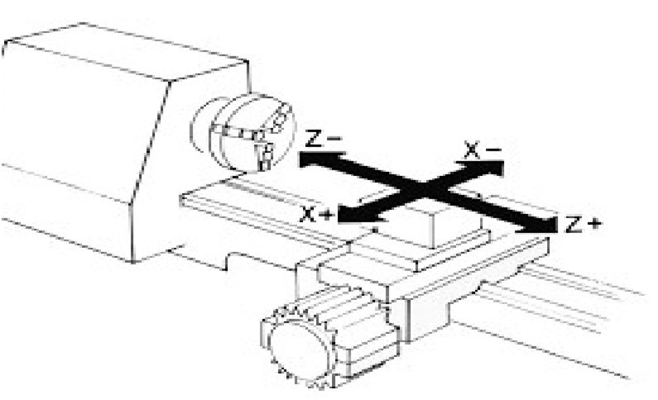X and Z axes for the lathe in descriptions above use the standard shown here:

# Exercises

I. Thread Cutting for Boxes with the Synchronization Screen:

Note: refer to instructions in other resources (such as “Turning Threaded Boxes” by John Swanson, Schiffer Publishing, 1999) for box threading tips and techniques.

Example 1: Single-start thread of 16 threads per inch (1/16” pitch).

1. Set “Revolutions” to number of threads to be cut around the cylinder. Suggest using “4” as a starting point.
2. Set “Distance” to .25 (four threads at 1/16” = ¼”).
3. With a 60-degree double angle cutter running in a drilling frame set parallel to the lathe’s spindle and driven by the overhead, test and adjust Spindle and Axis speed bars as necessary to get a usable combination of feed and speed (not so fast as to bog down cutter, not so slow as to burn the wood). If necessary, adjust “MaxSpd” setting on Configuration Screen to get usable combination.
4. Test “Left” and “Right” radio buttons to determine which type of thread will be cut (left hand or right hand).
5. Choose whether to cut “In” or “Out” based on what makes sense for your piece.
6. Cut thread. Typical good practice uses roughing and final cuts for each thread. If wood tends to fuzz up or chip out, it’s common practice to flow some CA glue into the rough threads and let it cure prior to the final cut.

Example 2: Four-start thread of 16 threads per inch (1/16” pitch, ¼” lead)

1. Set “Revolutions” to number of threads (of each start) to be cut around the cylinder. Suggest using “1” as a starting point.
2. Set “Distance” to .25 (1/4” lead). This will cut one continuous thread traveling ¼” as it goes once around cylinder.
3. Got to Index #1 Screen. Select “Div” toggle and set value in “Size” box to “4”. Note: would also work to select “Deg” toggle and set value in “Size” box to “90”.
4. Follow steps 3, 4, 5 & 6 in Example 1 above.
5. Return to starting point with cutter retracted from work using “In” or “Out” as appropriate.
6. Index spindle using either CW or CCW based on personal preference to get to starting point of next thread start. Re-engage cutter and repeat cutting process(es) in step 6 in Example 1 for Start #2. Retract cutter and return to start point of Start #2.
7. Repeat indexing and cutting procedures for Starts #3 and #4.